

**Experiment No.: 03**

**Title: Jenkins Installation**

# Batch: A1 Roll No.: 1814068 Experiment No.:03

**Aim:** To install Jenkins for Windows/Ubuntu

**Resources needed:** Internet

# Theory:

Jenkins is an open-source automation server written in Java. It is used to continuously build and test software projects, enabling developers to set up a CI/CD environment. It also supports version control tools like Subversion, Git, Mercurial, and Maven. Jenkins achieves Continuous Integration with the help of plugins. Plugins allow the integration of Various DevOps stages. To integrate a particular tool, you need to install the plugins for that tool. For example, Git, Maven 2 project, Amazon EC2, HTML publisher etc. It is built with Java and hence, it is portable to all the major platforms.

**Jenkins Features:**

* Adoption: Jenkins is widespread, with more than 147,000 active installations and over 1 million users around the world.
* Plugins: Jenkins is interconnected with well over 1,000 plugins that allow it to integrate with most of the development, testing and deployment tools.

# Procedure:

* 1. Install jdk 1.8
  2. Install Jenkins for windows or Ubuntu

# Results: (Document with screenshots)

1. All steps of installation
2. Jenkins dashboard
3. Download Generic Java Package(.war)

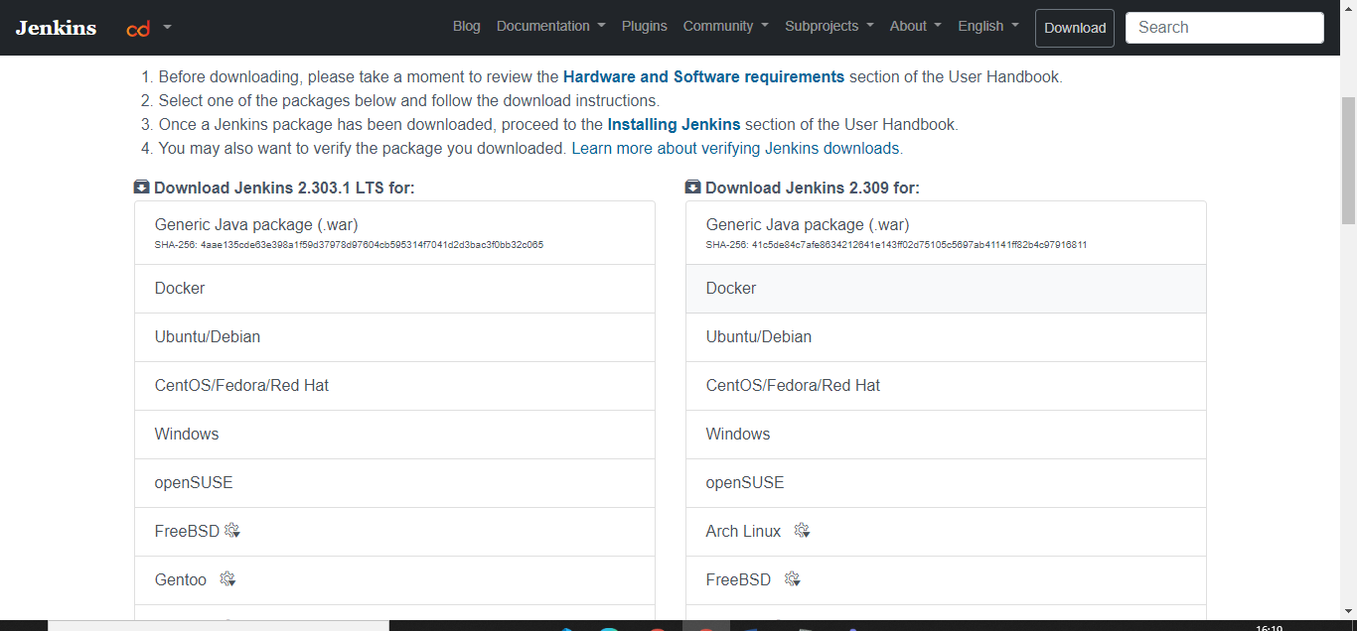

1. Java is already installed in the system

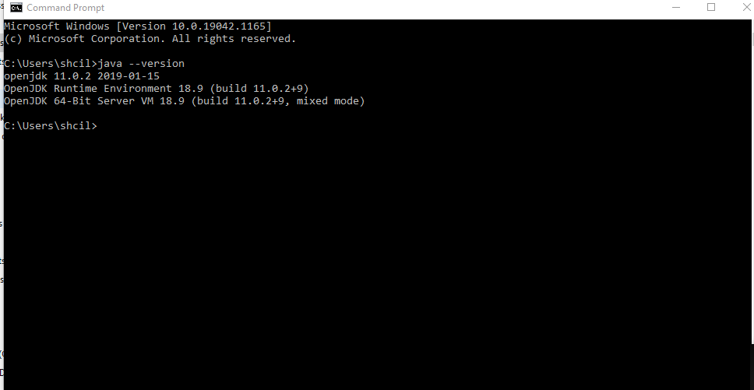

1. Run the jar file

Java –jar C:\Users\shcil\Downloads\jenkins.war

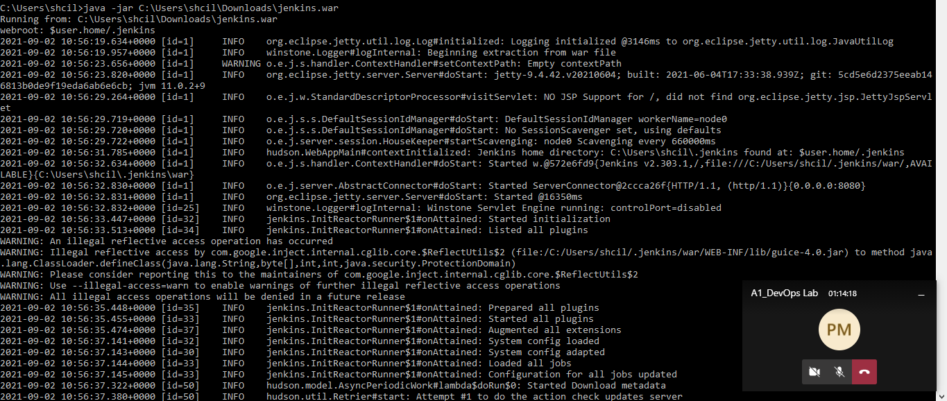

1. Note down the secret key

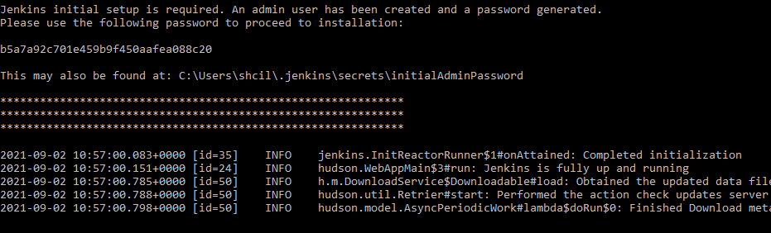

1. Run Jenkins on localhost8080 and copy the above secret key into administrator password.

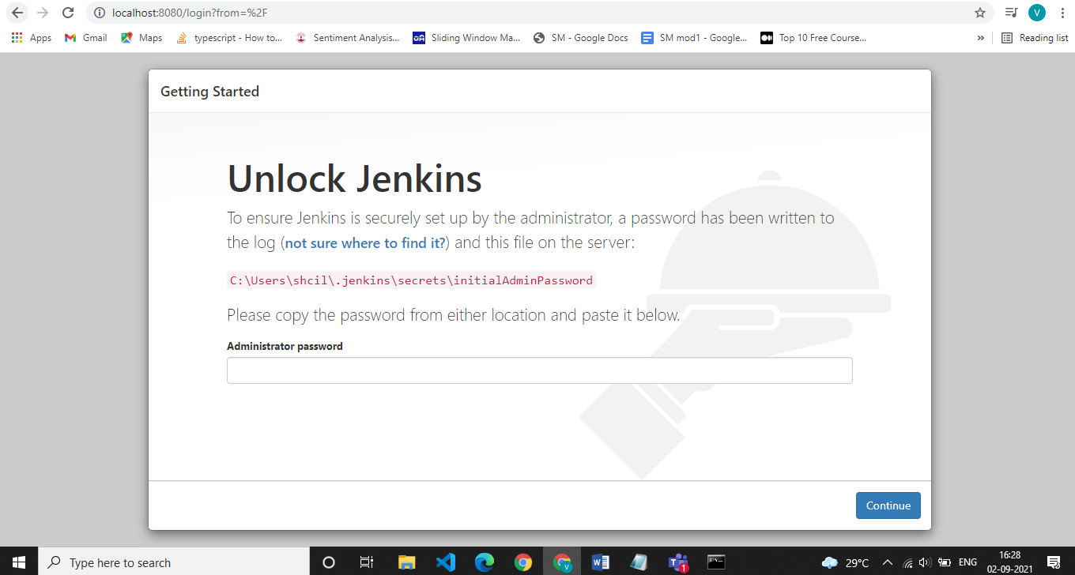

1. Install suggested plugins

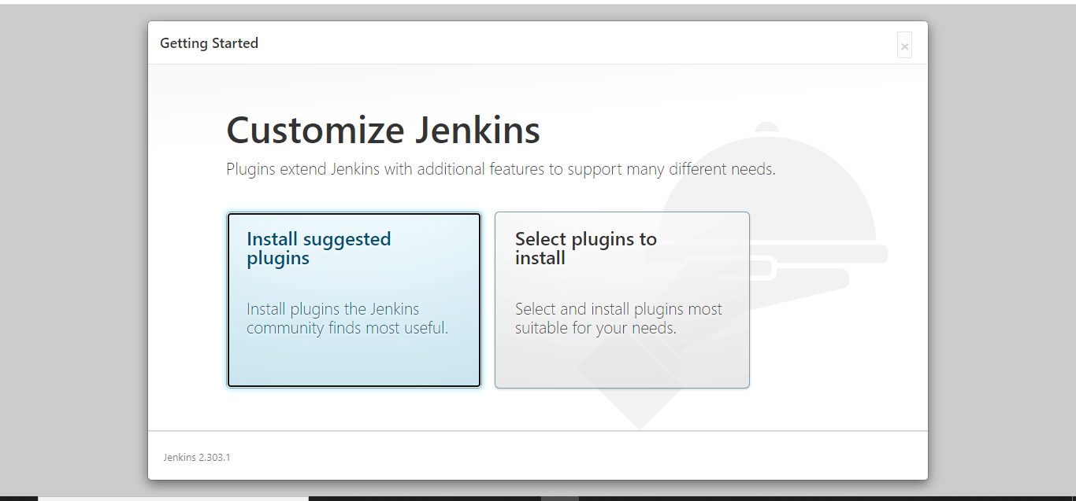

1. Make an admin

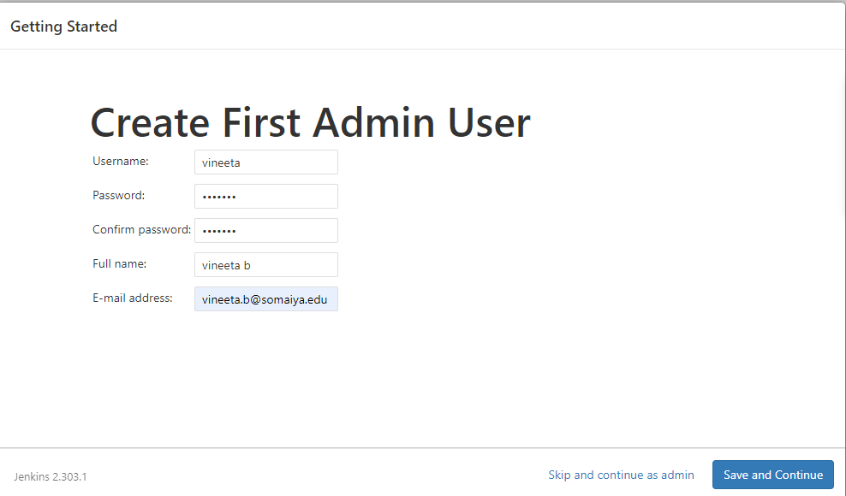

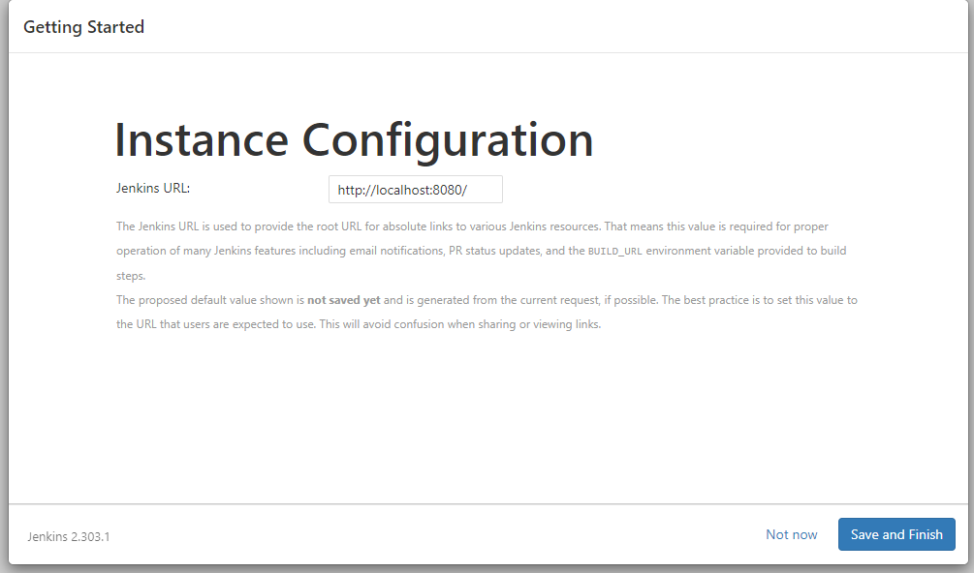

1. We have successfully installed Jenkins

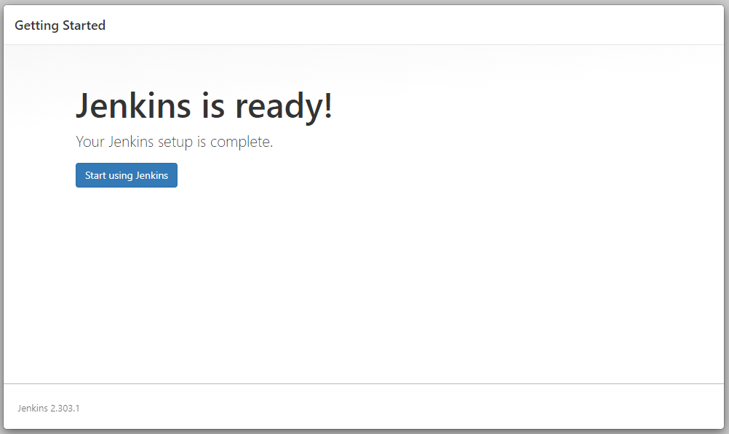

Dashboard

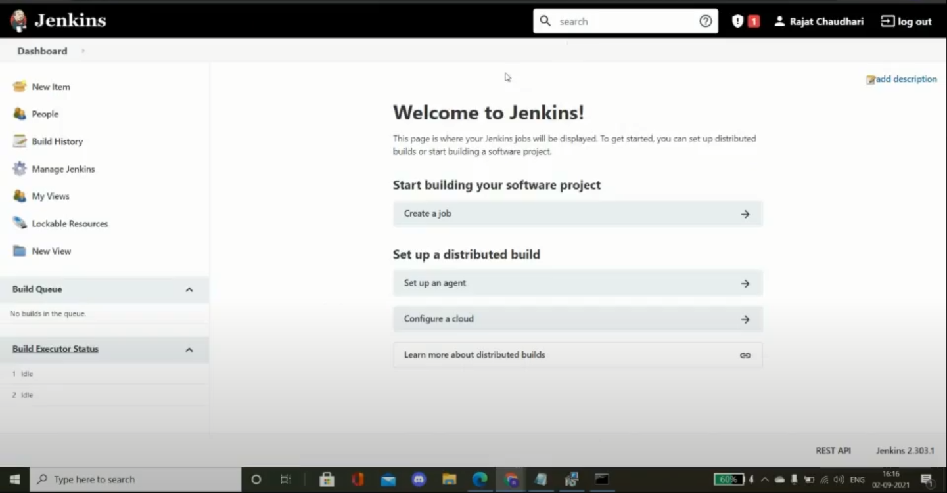

# Questions:

1. Explain various options/features of Jenkins dashboard.

Answer:

The Jenkins dashboard offers the following options:

New Item

People

Build History: Build history of the project

Manage Jenkins: Settings to customize the Jenkins dashboard

My Views

Lockable Resources

New View

The dashboard offers options to view build queues and build execution status. It also offers the user to create a new job.

# Outcome s:

CO1:Understand the basic concept and stakes of DevOps.

**Conclusion: (Conclusion to be based on the Results and outcome s achieved)**

**In this experiment we downloaded and installed Jenkins software on our system.**

**Grade: AA / AB / BB / BC / CC / CD /DD Signature of faculty in-charge with date**

**References:**

**Books/ Journals/ Websites:**

1. https://[www.jenkins.io/download/](http://www.jenkins.io/download/)
2. https://[www.blazemeter.com/blog/how-to-insta](http://www.blazemeter.com/blog/how-to-insta)ll-jenkins-on-windows
3. https://[www.jenkins.io/doc/book/installing/windows/](http://www.jenkins.io/doc/book/installing/windows/)
4. https://[www.digitalocean.com/community/tutorials/how-to-install-jenkins-on-ubuntu-](http://www.digitalocean.com/community/tutorials/how-to-install-jenkins-on-ubuntu-) 18-04
5. Effective DevOps: Building a Culture of Collaboration, Affinity, and Tooling at Scale, Jennifer Davis, Ryn Daniels, O'Reilly Media June 2016.
6. Practical DevOps: Implement DevOps in your organization by effectively building, deploying, testing, and monitoring code,Joakim Verona, Packt Publishing, 2nd Edition,2016